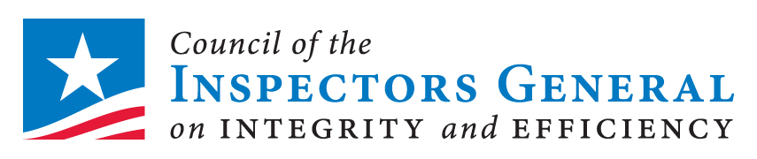
Federal Audit Executive Council Annual Conference
GSA Facility, One Constitution Square, 1275 First Street NE, Washington, DC 20417 (NoMa metro stop)

TUES | 11-27 Room 201
8:30 | Opening Remarks  Dr. Brett M. Baker, FAEC Chair
8:45 | IG Panel: OIG Community Status  Phyllis Fong, Chair, CIGIE  Jon Rymer, Chair, CIGIE Audit Committee  Kathy Tighe , Chair, RATB; GATB  Allison Lerner, IG, NSF  Dr. Brett M. Baker, Moderator
10:05 | BREAK
10:30 | CIGIE Investigations Committee  Carl Hoecker, Chair  IG, US Capitol Police
11:00 | Conference Costs and Other Issues  Brian Miller, IG, GSA
11:50to 1:15  Open | LUNCH
Optional Program
Health and Nutrition: A Better You Dr. Eric Berg, DC

Session is open to non-attendees
1:15  2:45  Open | Audit Community Training Needs Discussion  Jon Rymer, IG, FDIC  Chair, CIGIE Audit Committee  Session is open to OIG staff
 | BREAK
3:00 -4:30  Open | Leveraging Audit Management Software (TeamMate)  Billy Benge, Project Manager, TIGTA  Session is open to non-attendees  Any OIG staff can attend

WED | 11-28 Room 201
8:00 | Do Not Pay Business Center  Tom Vannoy  Do Not Pay Program Manager
9:00 | Be a Game Changer  Arleas Upton Kea  Administrative Director, FDIC
9:50 | BREAK
10:10 | Dangerous Curves Ahead:  Pursuit of Big Data in the 21st Century  Dave Williams, IG USPS
10:40 | The Recovery Operations Center as an Audit Community Resource  Carrie Hug  Director of Accountability, RATB
11:15- 1pm  12:00  Open | LUNCH
Optional Program
The Real CSI
a Frontline DVD

Session is open to non-attendees
1:00-1:50 | GAO Yellow Book Update  Jim Dalkin Director,  Financial Mgt and Assurance, GAO
1:50 | BREAK
2:10 | OMB E-Gov Initiatives  Mr. Dominic Sale, Portfolio Mgr (invited)
3:00 | OMB Grant Reform/Omni Circular  Victoria Collin  Policy Analyst, OMB
3:50 | Closing Remarks  Dr. Brett M. Baker, FAEC Chair

