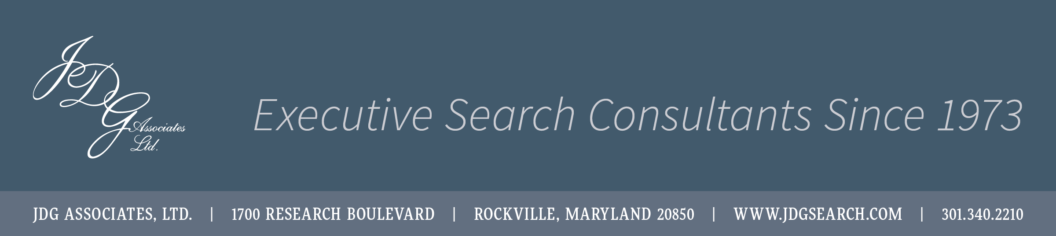

INSPECTOR GENERAL

WSSC WATER
Laurel, MD

Client

Established in 1918, WSSC Water (WSSC) is currently among the largest water and wastewater utilities in the nation, with a network of nearly 5,850 miles of fresh water pipeline and more than 5,600 miles of sewer pipeline. Serving 1.8 million residents across 1,000 square miles in Prince George’s and Montgomery counties, WSSC drinking water has always met or exceeded federal standards. WSSC Water boasts one of the highest employee retention rates of any employer in the Washington Metro Area due to the value and recognition given to employees along with competitive pay and generous benefits. For more information, please see https://www.wsscwater.com/.

Position Summary

The Inspector General (IG) provides policy direction for, and conducts, supervises, and coordinates audits, investigations, and management reviews of WSSC operations. The IG must act, operate, and maintain independence and simultaneously work as a key collaborative business partner with the Commissioners, the General Manager/CEO, and the executive leadership team to ensure that the Commission is operating efficiently and safely, and that revenue is correctly accounted for and allocated without any fraud, waste, and abuse.

Responsibilities:
- Ensures public accountability by preventing, detecting, and investigating fraud, waste, and abuse of Commission property or funds;
- Supervises nine staff and is responsible for training, evaluating work, counseling, and discipline.
- Assists the Commission by providing independent evaluation and recommendations to improve the efficiency of Commission programs, policies, practices, and operations;
- Examines, evaluates, and reports on the adequacy and effectiveness of the Commission’s systems of internal controls and their related accounting, financial, technology and operational policies;
- Ascertains the extent WSSC assets are accounted for and safeguarded from losses, and the adequacy of controls for safeguarding such assets;
- Evaluates compliance with governmental laws and regulations;
- Reports noncompliance and proposes ways to improve employee compliance with applicable law, policy, and standards of conduct;
- Consults with the Commission to develop a written work plan and establishes goals and priorities based on an assessment of relative risks;
- Submits reports that summarize the activities, findings, recommendations, and accomplishments of the office to be published on WSSC’s website;
- Oversees and directs an internal audit program including management reviews and financial, performance and compliance audits;
- Maintains a system of quality control and continual surveillance to ensure consistent adherence to applicable audit and investigation standards;
- Establishes audit and investigation guidelines, reviews guidelines to ensure they reflect current requirements, and identifies weaknesses in controls and fraud prevention;
- Collaborates with Commissioners and senior management to identify audit opportunities that lead to improved efficiencies and practices;
- Manages an anonymous hotline, conducts investigations into the validity of such reports and calls to identify audit or investigation opportunities;
- Issues subpoenas, with the assistance of the General Counsel’s Office, requiring the attendance and testimony of witnesses and the production of any evidence relating to any matter under investigation by the Office of the Inspector General;
- Provides advice and consultation to WSSC officials in conducting audit recommendations and correcting programmatic and operational weaknesses;
- Operates in a highly confidential manner to ensure effective work results that are consistent with state laws concerning public information and other legal considerations;
- Performs special reviews requested by the Commission, develops, and presents suggestions for improvement in operation or management of the functions of the Commission and its internal or external audit functions;
- Acts as liaison and representative for all external audits of WSSC;
- Coordinates with law enforcements agencies, agency personnel administrators, the State Ethics Commission, the Commission Board of Ethics, and other internal and external entities to avoid unnecessary disruption or duplication of effort in conducting any audit, analysis, or administrative investigation;
- May represent WSSC before industry and related professional groups, public agencies, the private sector, and the public.
Leadership/Management Skills
- Ensures that own behavior and the behavior of others is consistent with the highest ethical standards and aligns with the values of the organization.
- Proven ability to develop, coach, and mentor staff, providing constant feedback and clear direction.
- Demonstrated success in establishing and maintaining positive working relationships with others, both internally and externally, to achieve the goals of the organization.
- Strong ability to build credibility, organize effectively, and solve problems.
- Excellent oral and written communication and presentation skills.
Qualifications
  - 15+ years of progressively responsible executive-level management experience in the field of auditing, accounting, government operations and/or fiscal management that demonstrates the ability to effectively oversee a comprehensive fraud, waste and abuse and auditing program in a complex operating environment.
  - Comprehensive knowledge of auditing/accounting standards, principles, theories, techniques, and practices; internal auditing and internal controls; data processing operations and practices; as well as management principles and techniques;
  - Understand, interpret, and apply federal, state, and local laws, rules, regulations, policies, procedures, contracts, budgets, and labor/management agreements;
  - Make timely and effective decisions and implement results through strategic planning, and implementing and evaluating programs and policies;
  - Evaluate and analyze complex programs and operations, assess results, and then implement recommendations for improvements;
  - Plan, manage, and review the technical work of staff;
  - Establish and maintain effective working relationships with the Commissioners, all levels of management, and outside organizations;
  - Knowledge of theories, principles, practices, and program areas related to investigations;
  - Demonstrated skills and abilities demonstrating discretion and judgment in handling sensitive, confidential matters successfully.

Education: Bachelor’s degree in Accounting, Public Administration, Business Management, or related field; CPA preferred.
Location: Laurel, MD
Compensation: To $257,000 plus eligibility for performance-based bonus and generous benefits package.
Citizenship: U.S. Citizenship required.
Other: Completion of the WSSC Financial Disclosure statement within 30 days of employment and annually thereafter.
Contact:
Allie Marshall
JDG Associates, Ltd.
1700 Research Boulevard
Rockville, MD 20850
(301) 340-2210
marshall@jdgsearch.com

JDG Associates, established in 1973, is a leading provider of executive recruiting services to
federal/state/local government, associations and professional societies, Fortune 1000 corporations,
and a broad array of government contractors.

